27 September 2024 postcard

Last postcard of the trip, I'm afraid. If all goes well, we'll leave the hotel before breakfast tomorrow and get back to Tallahassee about midnight local time.

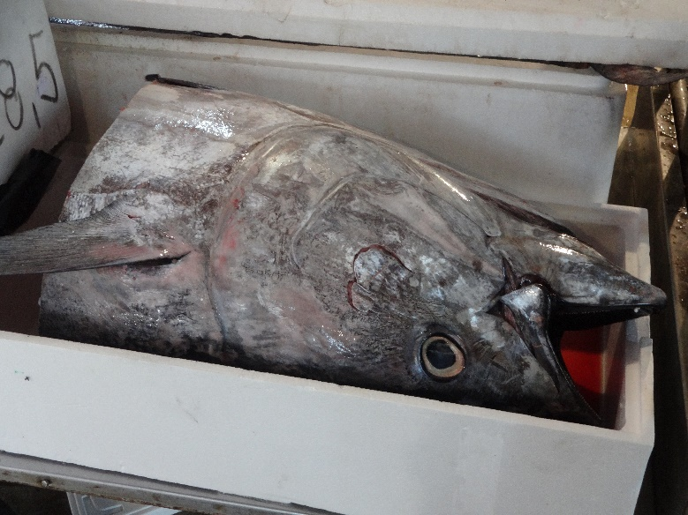But we accomplished what we wanted to do with our free day in Venice. David toured the Murano glass showroom behind St. Mark's cathedral (which I saw last year while he sat in the hotel with bronchitis) while I fulfilled a year-long ambition (a) to walk over the Rialto Bridge and (b) to visit the fish market, which I heard about but didn't get a chance to see on our last visit.

David doesn't like Murano glass any more than I do, but he said the experience was educational, and he would have swum the length of the Grand Canal rather than go along to watch me take pictures of dead fish. The tuna head shown here must have been 20 lb even without the rest of the fish attached.

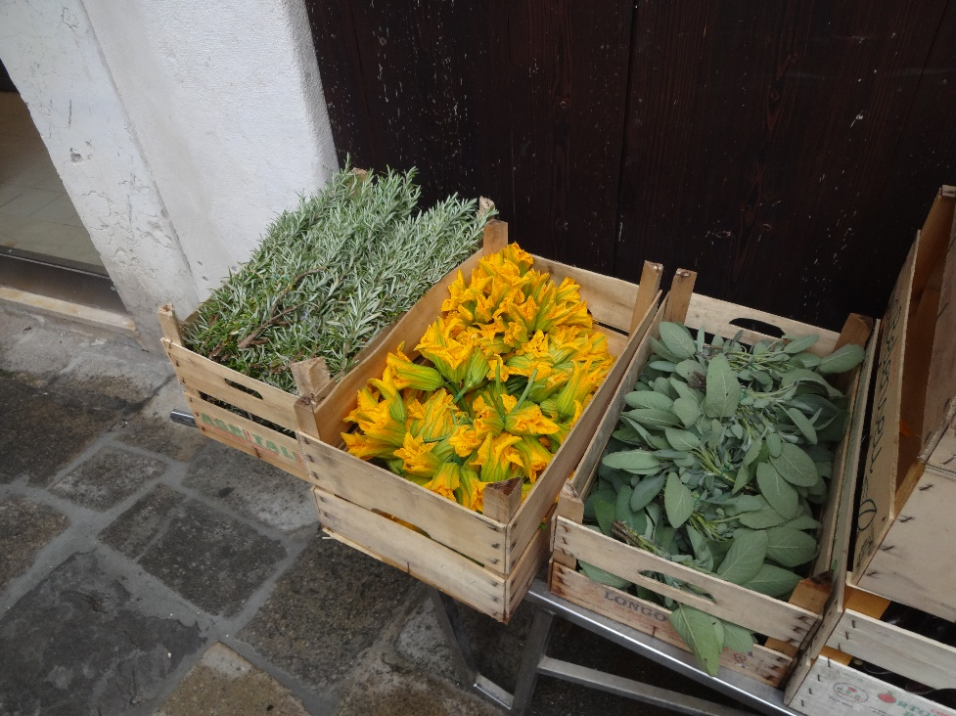The fish market was great and turned out to include a large veggie market as well. Here are crates of rosemary, squash blossoms, and sage, waiting to be unpacked and put on display. In addition, several butcher shops, cheese shops, and bakeries had their indoor shops along side. At first, I couldn't figure out what these flat, whitish slabs were, but they turn out to be artichoke bottoms! A guy with a very sharp knife and well-practiced moves was peeling the bottom halves of whole artichokes, slicing off the meaty bottom part into acidulated water (to prevent browning) , and discarding the tops! Surprisingly, many stands were selling sacks of "giuggiolo" fruit (jujubes, *Ziziphus jujuba*)

David and I rendezvoused at noon at the hotel, whence we walked toward the Academia art museum, prospecting for lunch. We settled at a sidewalk place (pretty touristy, but what can you do?) and gave Italian pizza one more chance. The pizza was actually pretty good, though not the equal (to our taste) of that from the late lamented Park's Twisted Pizza in Tallahassee.

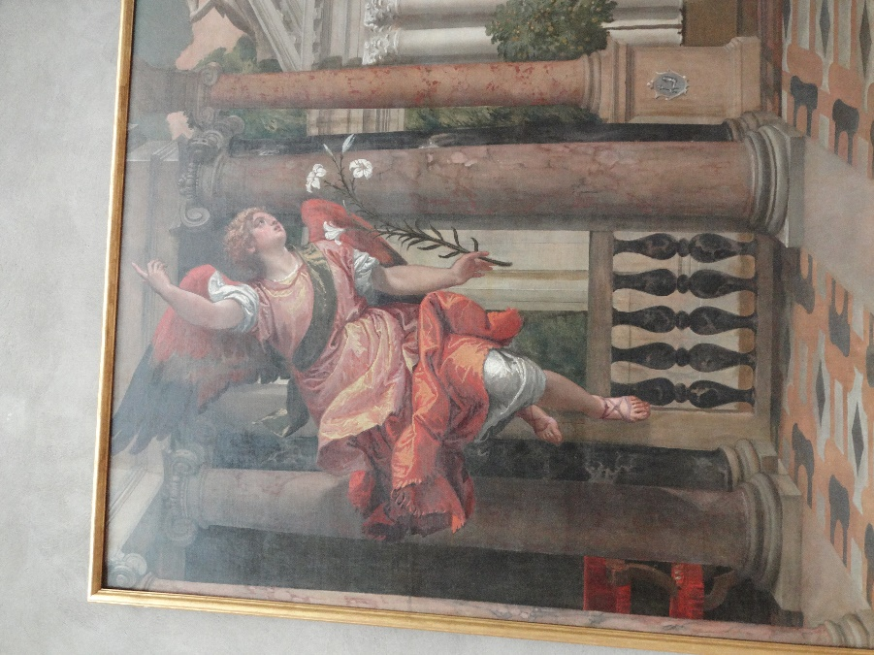We covered maybe a quarter of the Academia before our feet gave up, when we still had a 20-minute hike back to the hotel. Here's about half of a Veronese "Annunciation"; I particularly liked the angel

At 5 pm we met our Tour Director for the walk to a classical music concert Tauck arranged for us. It was in an old church, now a museum of Vivaldi and the music of his time. Here's a particularly interesting variation on the mandolin from their collection.

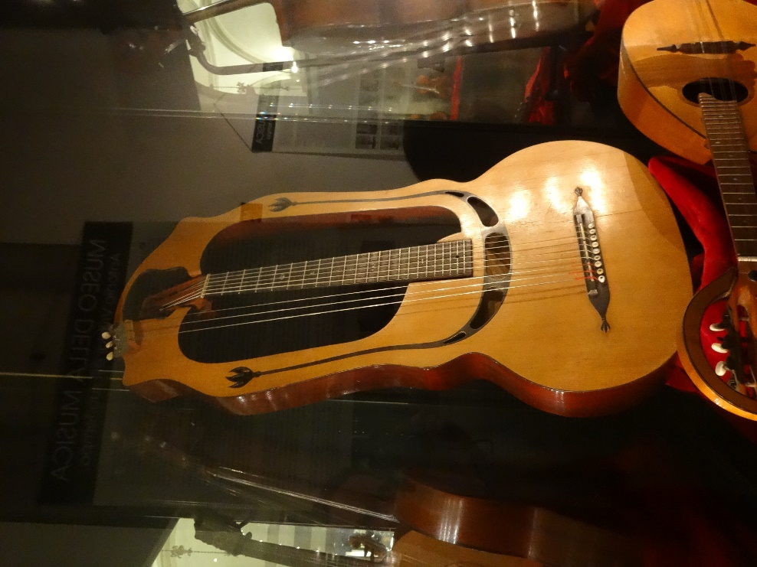

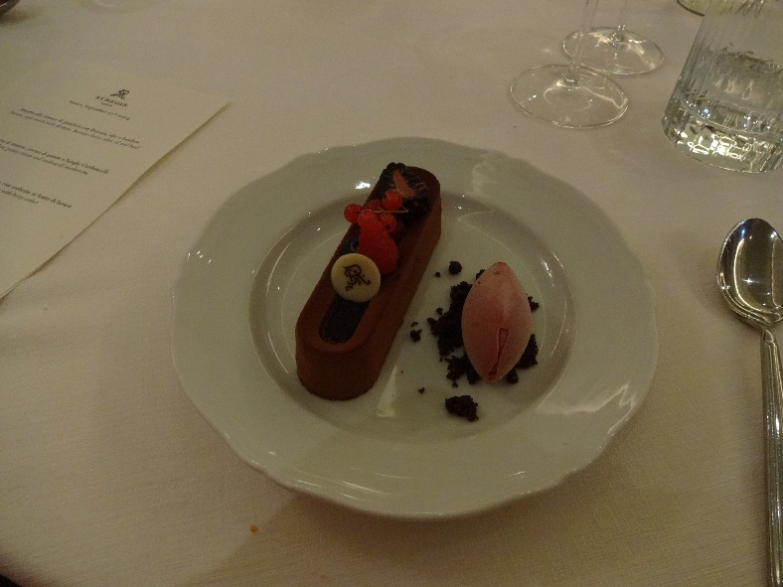After that, the farewell dinner at our hotel. Here's the dessert, billed as chocolate bavarian with berry sorbet, though that doesn't begin to describe it. Outstanding.

See you back in Tallahassee!